MED D - Blue MedicareRx (NEJE) - Drug Search
Rxmedicareplans.com Drug Search Tool
Related Documents

Description: This document provides guidance to the CCR on how to access and use the Drug Pricing Tool.

Rxmedicareplans.com Drug Search Tool

In order to utilize the Drug Search Tool, the CCR will:
Step | Action
1 | Access www.Rxmedicareplans.com.
2 | Select Coverage and Drug Pricing Tool.  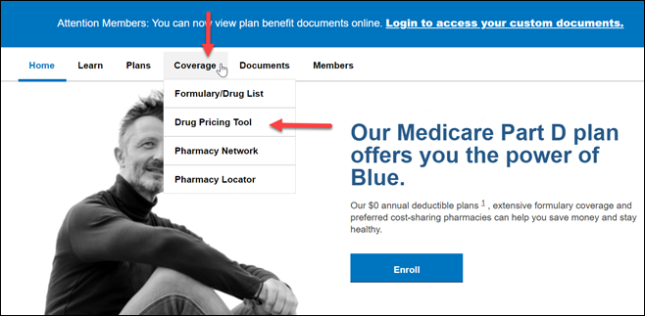
3 | Select Look up Covered Drugs. Make sure to select correct plan year between 10/1 and 12/31.  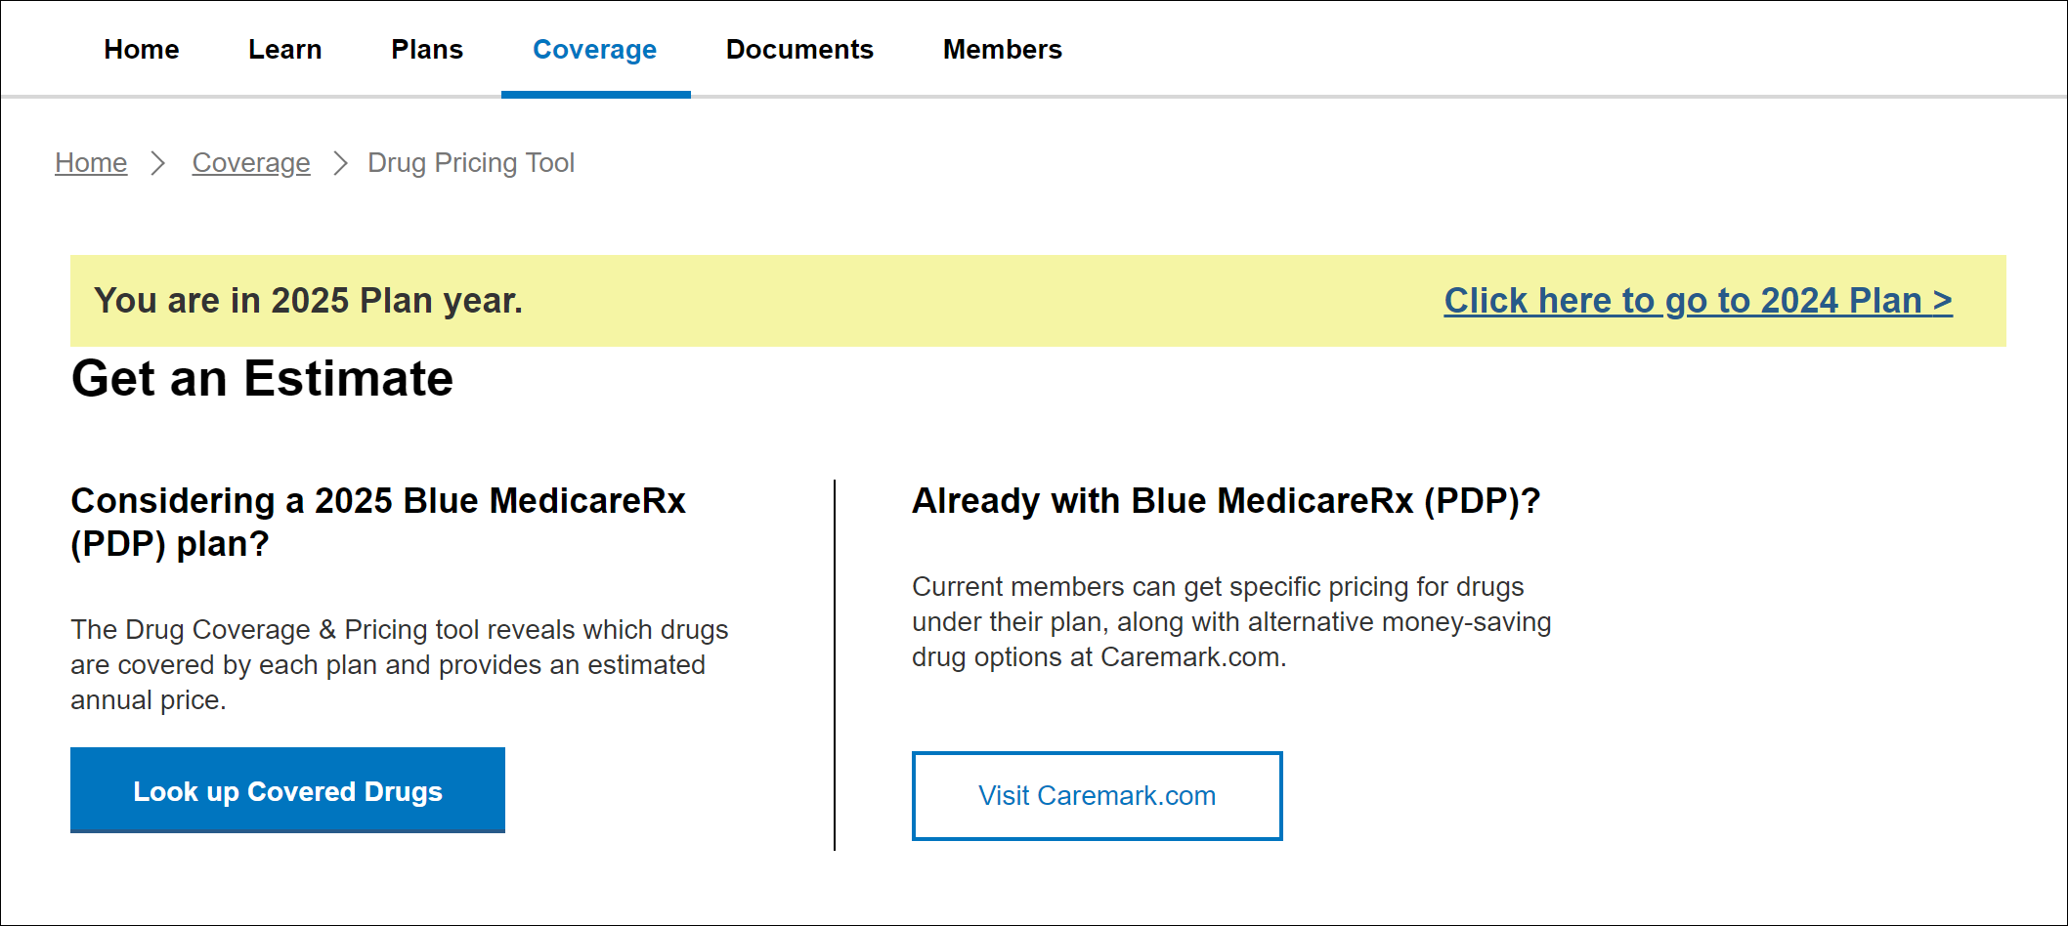
4 | - Enter the beneficiary’s zip code in the Zip Code pop-up box.  - Click on the Go to submit.  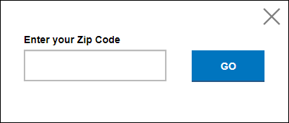
5 | - Enter the name or first few letters of the medication and select the appropriate strength and form from the drop down that appears once the drug has been entered and select Submit.  - Enter how much of this medication you take and how often.  - Enter how many refills you want.  - Enter how you would like to receive the prescription.  - Click Add to Drug Quote.  Result: The medication will appear listed underneath the fields where additional medications can be entered.
6 | - The list will indicate:  - The Drug  - Name  - Strength  - Form  - Quantity  - Day Supply (Mail or Retail)  - Symbol indicating if the drug is Brand or Generic  - Details of how the medication will be covered (or not) with each of the Blue MedicareRx plans  - Covered or Not Covered  - Tier  - Coverage Details  Some medications will have a quantity limit, so pay attention for the  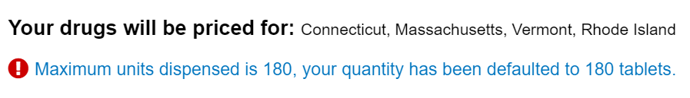  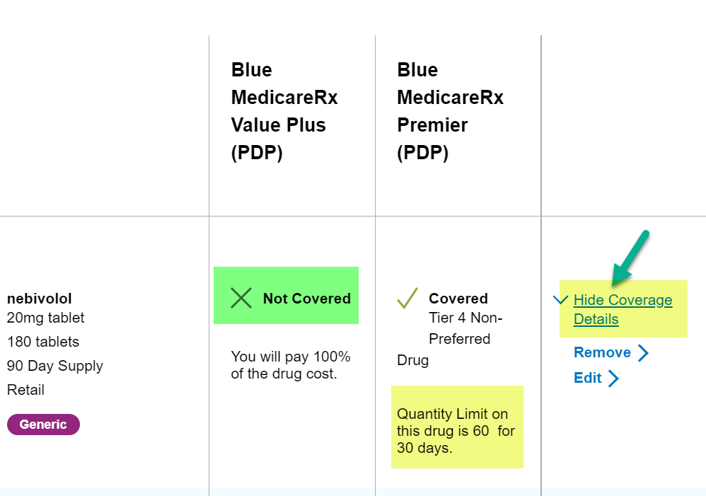  - Additional drugs can be entered and added to the list by repeating the previous steps. Edit Drugs in List is available throughout pricing tool.  *The below example uses nebivolol and SHINGRIX. BYSTOLIC is not on the formulary in 2025 so it was replaced with nebivolol.  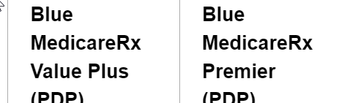  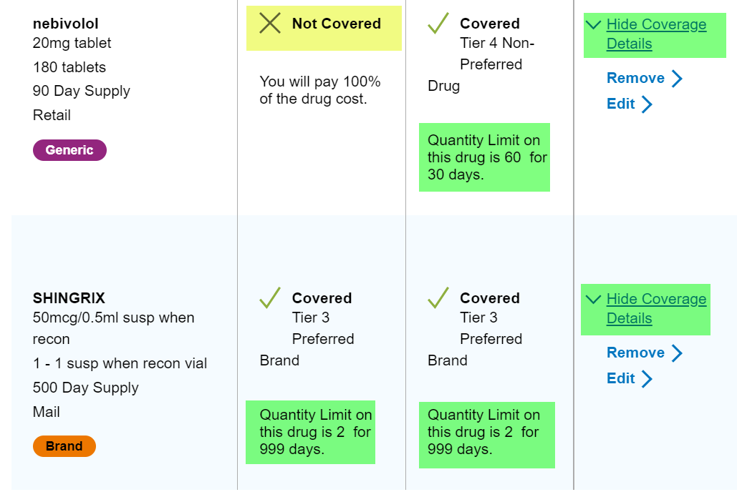
7 | When applicable, if a medication is not covered, but an alternative is equivalent, this message will show and give the option to click on the generic drug name to add the generic to the list.  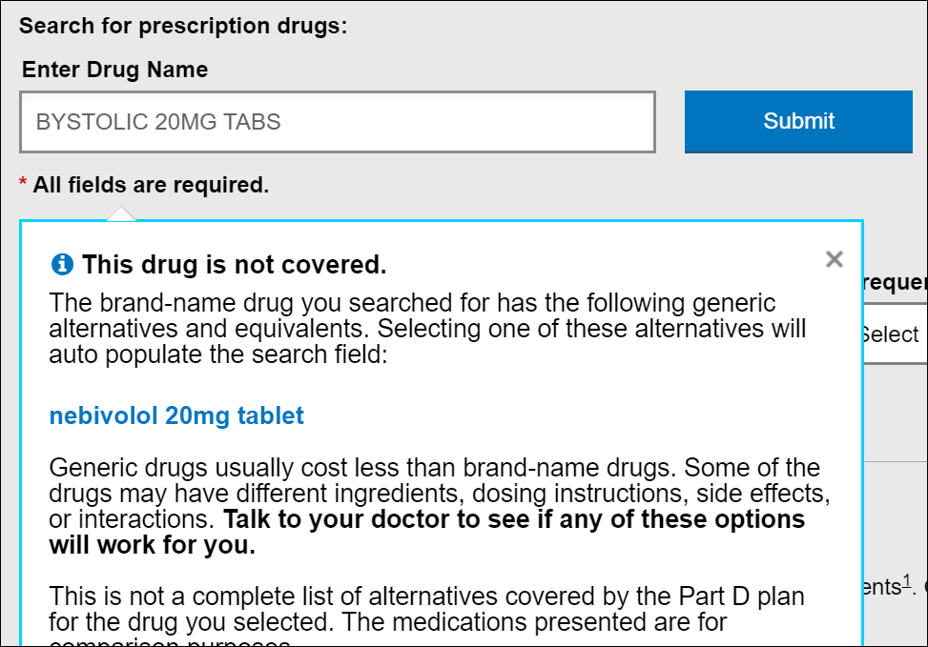
8 | Discuss important Coverage Details (Quantity Limits/Prior Authorization required/etc.).
9 | Once all medications have been added, click on the Price this Drug Quote button.
10 | Give all pricing details to the beneficiary.  Note: There are three (3) different views available and option to compare plans.  - Individual Drug Costs – shows cost in each phase of plan  - Total 2025 Costs – breaks costs down with premium and drug costs  - Monthly Costs – breaks costs down by month  Say pricing disclaimer to beneficiary:  Please note the prices quoted are estimates and may not reflect your actual out of pocket costs.  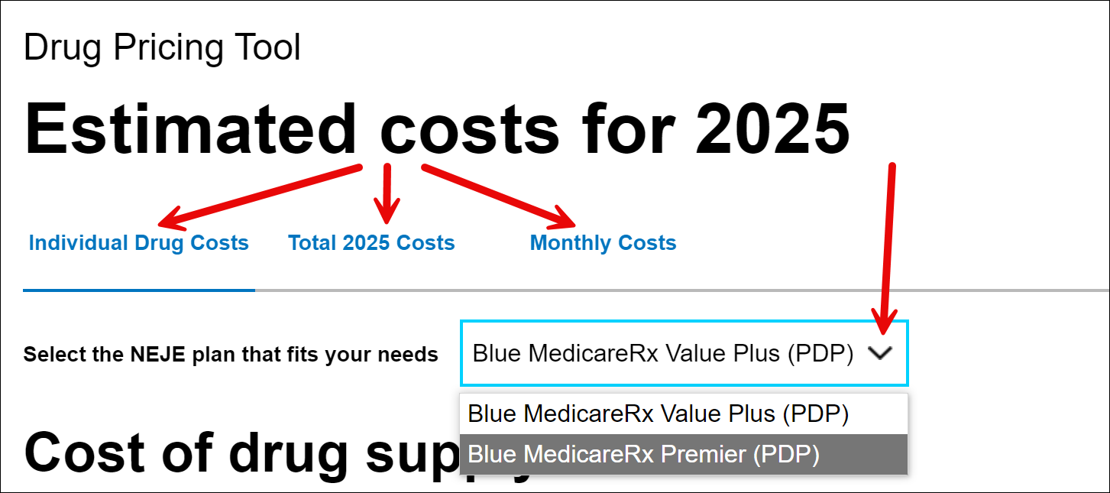
11 | Ask if they would like to receive Drug Quote via email.  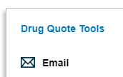  Email will come from information@rxmedicareplans.com with link to Drug Pricing Tool.  Provide the Quote number and Password  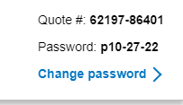  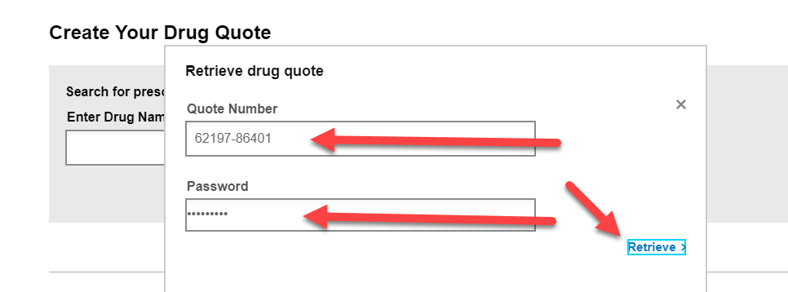
12 | Ask if there are any other benefit questions.
12 | If… | Then…
12 | Yes | - Address any benefit issues  - Document and close the call according to current policies and procedures  - Refer to Compass MED D - Call Documentation Job Aid.  Log Activity:  1003 - Plan Design Education  Resolution Time:  Information = immediate
12 | No | - Document and close the call according to current policies and procedures  - Refer to Compass MED D - Call Documentation Job Aid  Log Activity:  1003 - Plan Design Education  Resolution Time:  Information = immediate

Top of the Document

Related Documents
Universal Medicare D - Consultative Call Flow (CCF) Process

Parent SOP: CALL-0048: Medicare Part D Customer Care Call Center Requirements-CVS Caremark Part D Services, L.L.C.
Abbreviations/Definitions: Abbreviations / Definitions

Top of the Document
Not to Be Reproduced or Disclosed to Others without Prior Written Approval
ELECTRONIC DATA = OFFICIAL VERSION - PAPER COPY = INFORMATIONAL ONLY

